Stepper Motor Connection Options
Stepper motors with more than 5 wires can me connected in different ways. As this graph illustrates, each has advantages and disadvantages. Notice that although parallel windings appear to give the best performance, they do require a more expensive bi-polar driver and more than 40% additional drive current...
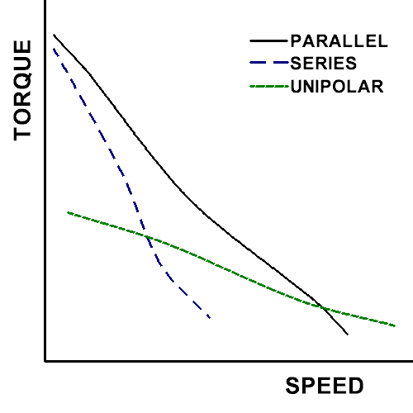

Comparing Wiring Options for Stepper Motors
Wiring | Motor  Wires | Connections | Resistance  in Ohms | Inductance  in millihenries | Current  in Amperes | Voltage  in Volts | Holding Torque
Unipolar | 4 | not an option | as rated | as rated | as rated | as rated | as rated
Unipolar | 5 | Common wire to + power, then A+,A-,B+,B- to unipolar driver
Unipolar | 6 | Short common A to common B, connect common wires to + power, then A+,A-,B+,B- to unipolar driver
Unipolar | 8 | Connect A coils in series (A+' to A-'), and B coils in series (B+' to B-'), short the center between A to the center between B (A+'/A-' to B+'/B-'), connect all those center wires to + power, then A+,A-,B+,B- to unipolar driver
Bipolar  -Series | 4 | A+,A-,B+,B- to bipolar driver | twice the rated value | 4 times the rated value | 0.707 * rated | 1.414 * rated | 1.414 * rated
Bipolar  -Series | 5 | not an option
Bipolar  -Series | 6 | Common A and common B are held apart and not connected to anything. A+,A-,B+,B- to bipolar driver with 41% higher voltage than the motor rating.
Bipolar  -Series | 8 | Connect A coils in series (A+' to A-'), and B coils in series (B+' to B-'), then A+,A-,B+,B- to bipolar driver with 41% higher voltage than the motor rating.
Bipolar  -Half Coil | 4 | not an option, unless wired internally by mfgr (very rare) | as rated | as rated | as rated | as rated | as rated
Bipolar  -Half Coil | 5 | not an option
Bipolar  -Half Coil | 6 | not an option
Bipolar  -Half Coil | 8 | Only one A coil and one B coil are connected. A+,A+',B+,B+' to bipolar driver (A-, A-', B-, B-', are held apart, disconnected from everything)
Bipolar  -Parallel | 4 | not an option, unless wired internally by mfgr | half the rated value | as rated | 1.414 * rated | 0.707 * rated | 1.414 * rated
Bipolar  -Parallel | 5 | not an option
Bipolar  -Parallel | 6 | not an option
Bipolar  -Parallel | 8 | A coils in parallel (A+ to A-, A+' to A-'), B coils in parallel (B+ to B-, B+' to B-'), each set (A+/A-, A+'/A-', B+/B-, B+'/B-') to bipolar driver with 41% more current capacity than the motor rating.
Keep in mind, the power out of a motor pretty much equals the power in. In electronics, power (in watts) = voltage times amperage. If you run a unipolar motor at 5 watts (e.g. a 5 volt 1 amp) and a bipolar motor wired parallel at 5 watts (e.g. a 5 volt 1 amp motor running parallel at 3.5 volt 1.4 amp) you are going to get about the same torque from each. There is only one coil wound bifilar on the same core. if you connect both starts and ends respectively the only thing you are doing is doubling the wire's effective transversal section (reducing the coil resistance ) versus the unipolar. Number of turns is still the same. And Holding torque equals Ampere-turns.
So when you are trying to get the best bang for your buck, and you include the cost of the driver, and the requirement for an 8 wire motor, you can probably get a unipolar driver with the same power rating as a bi-polar driver for less money and put that savings into bigger unipolar motors. On the other hand, if you find a killer deal on some 8 wire motors, you will probably get better low end torque if you spend the extra on a parallel bi-polar driver.
Here is a real world example that illustrates this point: The Vexta PK266-02B motor is commonly available for around $30. It is a 6 wire motor, so Parallel Bipolar is not an option. Starting from the datasheet provided by the mfgr for the motor, we can take the unipolar torque curve shown on the right, and cut out the part up to 500 RPM (since that is all they provide on the other, bipolar, graph) then turn the line on the unipolar side green (to make it easier to see) and resize it on top of the bipolar graph. You see the result on the left. The bipolar driver, starts out with more torque, but looses power quickly as the RPM climb. On a CNC mill, this limits your traverse speed, although it does give you better cutting drive.
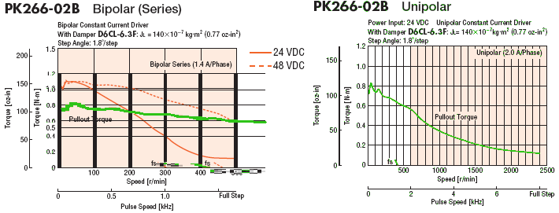
If you need more proof, here is a video of actual side by side comparisons.http://www.youtube.com/watch?v=pNGFPJETF5s
See:
- Wiring for information on the different types of wiring inside a stepper motor and finding which wire is which.
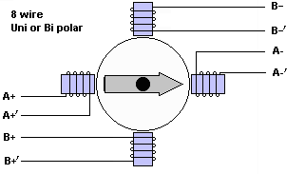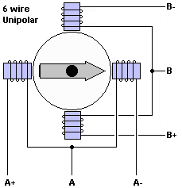

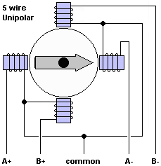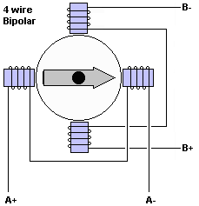
4 Wire Series or Parallel
Good Unipolar Stepper Motors

How to Wire Your Stepper

by avayan • December 27, 2011 • 0 Comments
You have a stepper motor and you are wondering how to wire it to your driver board. If you have a four lead motor, then that is plenty easy. But what if the motor has five, six or even eight wires? What can you do with them?
In this article I do not detail how to determine which phase is which as I have covered that topic on a different posting. What I want to discuss are the implications of wiring your motors one way or another. Another? Is there more than one way? In some cases yes! So lets take a looksie, shall we?
The Four Wire Stepper Motor
There is not much detailing here. The four wire stepper denotes a single possible configuration and that is of a bipolar stepper motor. We do not need to bore us with details such as whether this motor is variably reluctance, permanent magnet or hybrid as that only relates to construction. What we need to realize is that two wires are for PHASE A and the other two wires are for PHASE B. Which one is PHASE A and which one is PHASE B is kind of arbitrary.
If you have the motor datasheet then you know which wires represent which. But if you do not have this document, just do a quick continuity test and determine which two wires are connected together through an inductor. You can also use a simple BACK EMF test in which you short two leads together. If it is harder to move the rotor, then those two wires form one of the phases. If the rotor moves as easy as with no wires crossed over, then those two wires are not connected through a winding. Keep on going until you find both phases.
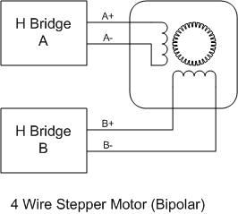
FIGURE 1
Once you have determined both phases, you can wire your motor as shown on the picture above. If you do not know which one of the phases is A and which one is B, just wire the motor until you get the direction you want.
The Five Wire Stepper
This motor is also equally easy to deal with as it can only be wired as an unipolar stepper motor. There is really no way to use this motor in a bipolar configuration as all the center taps have been shorted together. Do note this motor style is quite rare. I think these motors were more common a few years ago when unipolar motors were much more cost effective. Today, however, since driving bipolar motors is not a superbly expensive endeavor, the five wire stepper motor is not as common as it used to be. Instead, the six wire stepper motor has replaced the five wire stepper motor because of what we will see next. If you do happen to get your hands on a five wire stepper motor, here is how you wire it:
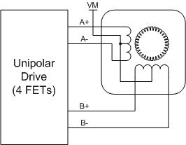
FIGURE 2
But how do we learn which the center tap is? Chances are you will not have the documentation for this motor. If this is the case, then you will need to do a quick resistance measurement. You will find that a winding to center tap measurement will be either half or a quarter the measurement from a winding to winding measurement. The problem with this motor, however, is that you do need to get the order of the phases correct or you will not be able to step it correctly. What I prefer to do is rotate the rotor while looking at each winding output with an oscilloscope. You will then get the right sequencing order.
The Six Wire Stepper
We can now start to complicate things. As it turns out, the six wire stepper is optimized to operate as a unipolar stepper motor but it is rather doable to use it as a bipolar stepper motor as well. The trick, however, is that there are multiple ways of wiring the motor as bipolar and it all depends on what you will want to achieve. For example, do you want speed, or do you want torque? Maybe you want both? Well, I can only promise one or the other by utilizing conventional drive technology. If you want both (torque and speed) you will need to resort to some highly advanced drive technology, which although available out there, is not in the$5.00 range. Not yet at least…
So lets first see how to wire the six wire stepper as a unipolar motor:
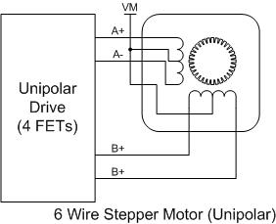
FIGURE 3
Notice the stepper is wired very similarly to the five wire stepper, except that in this case you had to wire both center taps together. Determining the order of the phases in this case is a little bit simpler too. Since you know which three wires correspond to a phase, it is clear you cannot mix them together as easily. Wait! Do I know which wires pertain to a phase? Sometimes you do and sometimes you don’t. Don’t think because you see a six pin connector that the first three wires are PHASE A and the other three wires are PHASE B. This may be true in a motor you paid top money for and for which a datasheet exists. However, just the other day I bought a motor at a surplus place (in China, to add another intriguing data point) and the connector pins were all messed up with no sense in their ordering scheme. I bet that is why the motor was in a surplus store, and not in a distributor’s warehouse…
Fear not! The same resistance/inductance test can be used to determine which wire is which. Do note that if you use inductance, you will find the inductance from winding side to center tap to be a 1/4 of the L value from side to side. Why? Because this is a mutual inductance construction and you can no longer use the same inductance in series equation. If you use resistance measurement, however, you will then find that the resistance from side to center tap is 1/2 of the resistance from side to side. I portray these concepts below:
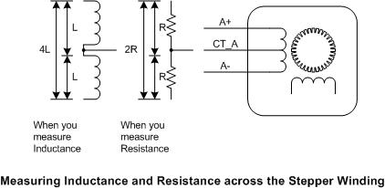
FIGURE 4
OK, now we can follow with the truly messy stuff. A six wire stepper wired as unipolar is a no brainer. Wiring it as a bipolar, however, can get tricky. Not because it is hard, but because it depends on what you want to do. To wire as bipolar we will ignore one of the winding connections, either the center tap, or one of the sides. Both methods will have different implications; that is advantages and disadvantages. I portray below both implementations and then we can see what kind of goodies and damage we are dealing with.
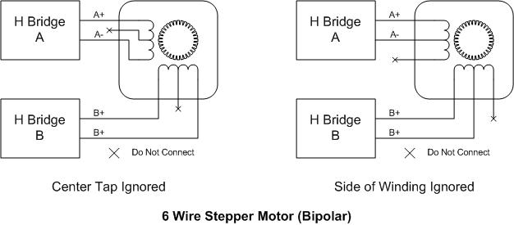
FIGURE 5
When we ignore the center tap, we get an inductance of 4L as seen on FIGURE 4. This may seem like just a trivial conclussion but the implications are massive. What this means is the current will take four times as long to increase through the magnetic field. Hence, it is safe to assume the magnetic field will also take four times as long to build up and cause motion. If you arae thinking this will increase the trouble of moving the stepper faster and faster, then you are correct. What happens is that as the stepping rate is increased, a new step is issued long before the current step can take place. In mechanical terms, the rotor starts to lag the revolving magnetic field and eventually it falls behind with the motor stalling and losing synchronization. In other words, precisely what you don’t want.
What is the solution? There are only two things I can think of. Either you increase the voltage, which increases the rate at which the current charging through the winding goes up, or decrease the inductance. Before I go into the inductance, let me state that increasing the voltage is an excellent idea if you can. However do note that stepper drivers have a maximum voltage associated with them. You may also have very little flexibility on the power supply voltage, in which case this discussion is over long before it started.
Hence, decreasing the inductance is the only way. If you can get a stepper designed with lower inductance, then awesome! If not, you can always resort to the left side of FIGURE 5. Notice we have ignored one of the winding sides instead of the center tap. What does this buys us? Well, for one now your inductance is equal to L, instead of 4L as shown on FIGURE 4, which means the rate of current change is quadrupled from the center tap version. As a result, you should easily see the maximum speed increasing accordingly.
There is one caveat, however. Perhaps you noticed that as we eliminate half of the winding per phase we are hindering the amount of torque the motor can put out. After all, half of the copper on the motor is not being used and if the current is being regulated to the same value, we should expect half of the available torque present. Like I stated before, you can either get torque or speed, hardly both. When you eliminate the half winding the motor will be able to move faster but only as long as the torque constraints are met. That will of course depend on the application.
WHAT NOT TO DO!!!
After so much discussion on tips and tricks, the reader may feel intrigued about one connection style we have not discussed. What if instead of ignoring half of the winding we connect both winding in parallel? Shouldn’t we gain from reduced inductance and resistance? YEAH BABY!!! Lets do it!
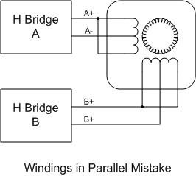
OK, Sorry to burst your bubble, but this is not going to work. Due to the mutual inductance what will actually happen is that one magnetic field will cancel the other and the motor will never move. But just so that you feel better, I did make this mistake once.
If we want to take on the advantage of a parallel connected winding we will need the eight wire stepper. This posting is already too long, but I may study it in a future release. In the mean time, I do hope you are wired!
Tags: bipolar unipolar stepper

Stepper Motors
A stepper motor is a motor controlled by a series of electromagnetic coils. The center shaft has a series of magnets mounted on it, and the coils surrounding the shaft are alternately given current or not, creating magnetic fields which repulse or attract the magnets on the shaft, causing the motor to rotate.
This design allows for very precise control of the motor: by proper pulsing, it can be turned in very accurate steps of set degree increments (for example, two-degree increments, half-degree increments, etc.). They are used in printers, disk drives, and other devices where precise positioning of the motor is necessary.
There are two basic types of stepper motors, unipolar steppers and bipolar steppers.
Unipolar Stepper Motors
The unipolar stepper motor has five or six wires and four coils (actually two coils divided by center connections on each coil). The center connections of the coils are tied together and used as the power connection. They are called unipolar steppers because power always comes in on this one pole.
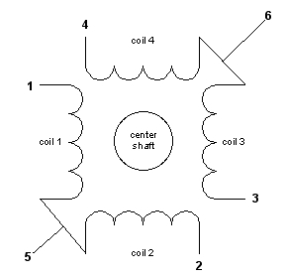
Bipolar stepper motors
The bipolar stepper motor usually has four wires coming out of it. Unlike unipolar steppers, bipolar steppers have no common center connection. They have two independent sets of coils instead. You can distinguish them from unipolar steppers by measuring the resistance between the wires. You should find two pairs of wires with equal resistance. If you’ve got the leads of your meter connected to two wires that are not connected (i.e. not attached to the same coil), you should see infinite resistance (or no continuity).
Like other motors, stepper motors require more power than a microcontroller can give them, so you’ll need a separate power supply for it. Ideally you’ll know the voltage from the manufacturer, but if not, get a variable DC power supply, apply the minimum voltage (hopefully 3V or so), apply voltage across two wires of a coil (e.g. 1 to 2 or 3 to 4) and slowly raise the voltage until the motor is difficult to turn. It is possible to damage a motor this way, so don’t go too far. Typical voltages for a stepper might be 5V, 9V, 12V, 24V. Higher than 24V is less common for small steppers, and frankly, above that level it’s best not to guess.
To control the stepper, apply voltage to each of the coils in a specific sequence. The sequence would go like this:
Step | wire 1 | wire 2 | wire 3 | wire 4
1 | High | low | high | low
2 | low | high | high | low
3 | low | high | low | high
4 | high | low | low | high
To control a unipolar stepper, you use a Darlington Transistor Array. The stepping sequence is as shown above. Wires 5 and 6 are wired to the supply voltage.
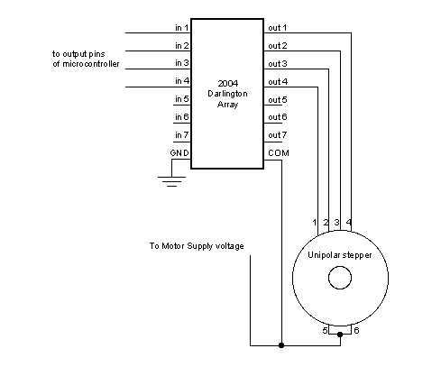
To control a bipolar stepper motor, you give the coils current using to the same steps as for a unipolar stepper motor. However, instead of using four coils, you use the both poles of the two coils, and reverse the polarity of the current.
The easiest way to reverse the polarity in the coils is to use a pair of H-bridges. The L293D dual H-bridge has two H-bridges in the chip, so it will work nicely for this purpose.
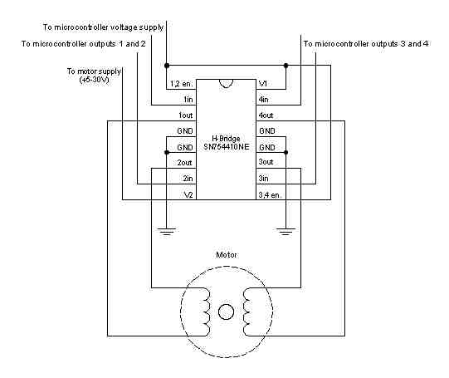
Once you have the motor stepping in one direction, stepping in the other direction is simply a matter of doing the steps in reverse order.
Knowing the position is a matter of knowing how many degrees per step, and counting the steps and multiplying by that many degrees. So for examples, if you have a 1.8-degree stepper, and it’s turned 200 steps, then it’s turned 1.8 x 200 degrees, or 360 degrees, or one full revolution.
Two-Wire Control
Thanks to Sebastian Gassner for ideas on how to do this.
In every step of the sequence, two wires are always set to opposite polarities. Because of this, it’s possible to control steppers with only two wires instead of four, with a slightly more complex circuit. The stepping sequence is the same as it is for the two middle wires of the sequence above:
Step | wire 1 | wire 2
1 | low | high
2 | high | high
3 | high | low
4 | low | low
The circuits for two-wire stepping are as follows:
Unipolar stepper two-wire circuit:
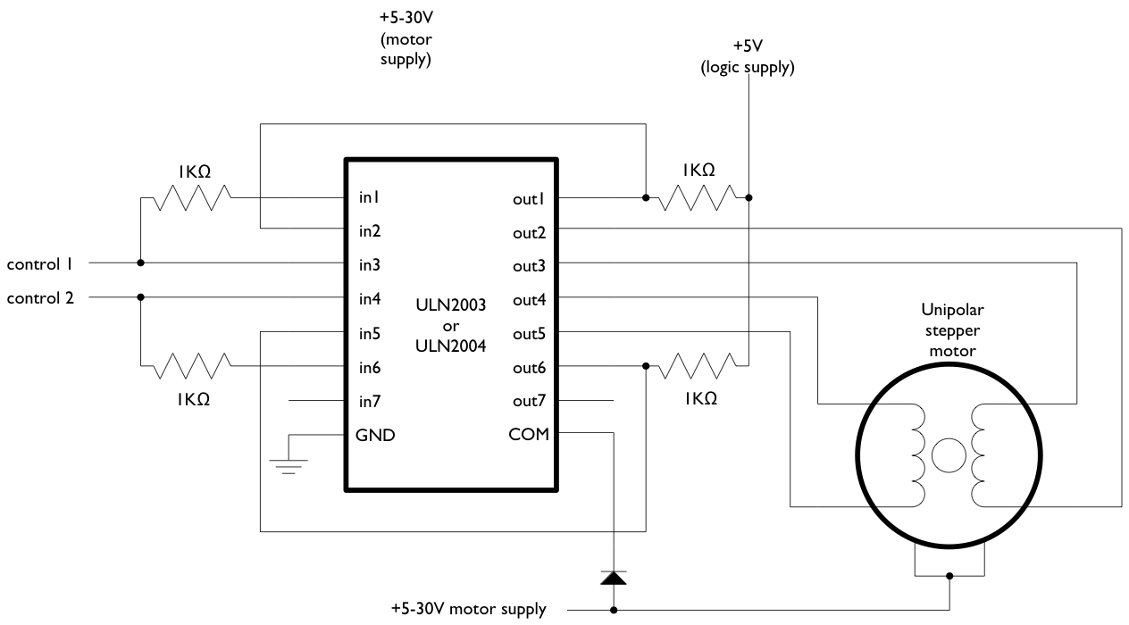
Biolar stepper two-wire circuit:
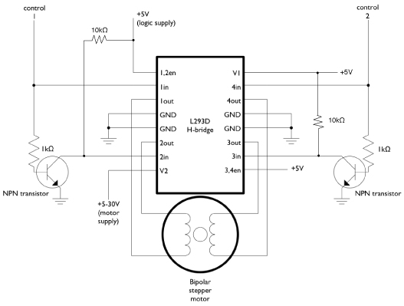
Programming the Microcontroller to Control a Stepper
Because both unipolar and bipolar stepper motors are controlled by the same stepping sequence, we can use the same microcontroller code to control either one. In the code examples below, connect either the Darlington transistor array (for unipolar steppers) or the dual H-bridge (for bipolar steppers) to the pins of your microcontroller as described in each example. There is a switch attached to the microcontroller as well. When the switch is high, the motor turns one direction. When it’s low, it turns the other direction.
The examples below use the 4-wire stepping sequence. A two-wire control program is shown for the Wiring/Arduino Stepper library only.
Wire pins 9-12 of the BX-24 to inputs 1-4 of the Darlington transistor array, respectively. If you’re using the PicBasic Pro code, it’s designed for a PIC 40-pin PIC such as the 16F877 or 18F452. Use pins PORTD.0 through PORTD.3, respectively. If you’re using a smaller PIC, you can swap ports, as long as you use the first four pins of the port.
Note that the wires read from left to right. Their numbers don’t correspond with the bit positions. For example, PORTD.3 would be wire 1, PORTD.2 would be wire 2, PORTD.1 would be wire 3, and PORTD.0 would be wire 4. On the BX-24, pin 9 is wire 1, pin 10 is wire 2, and so forth.
BX-24 code:
dim motorStep(1 to 4) as byte
dim thisStep as integer

Sub main()
call delay(0.5) ' start program with a half-second delay

dim i as integer

' save values for the 4 possible states of the stepper motor leads
' in a 4-byte array. the stepMotor routine will step through
' these four states to move the motor. This is a way to set the
' value on four pins at once. The eight pins 5 through 12 are
' represented in memory as a byte called register.portc. We will set
' register.portc to each of the values of the array in order to set
' pins 9,10,11, and 12 at once with each step.

motorStep(0) = bx0000_1010
motorStep(1) = bx0000_0110
motorStep(2) = bx0000_0101
motorStep(3) = bx0000_1001

' set the last 4 pins of port C to output:
register.ddrc = bx0000_1111

' set all the pins of port C low:
register.portc = bx0000_0000

do
' move motor forward 100 steps.
' note: by doing a modulo operation on i (i mod 4),
' we can let i go as high as we want, and thisStep
' will equal 0,1,2,3,0,1,2,3, etc. until the end
' of the for-next loop.

for i = 1 to 100
thisStep = i mod 4
call stepMotor(thisStep)
next

' move motor backward
for i = 100 to 1 step -1
thisStep = i mod 4
call stepMotor(thisStep)
next
loop

End Sub

sub stepMotor(byref whatStep as integer)
' sets the value of the eight pins of port c to whatStep
register.portc = motorStep(whatStep)

call delay (0.1) ' vary this delay as needed to make your stepper step.
end sub

PicBasic Pro code:
start:
High PORTB.0

' set variables:
x VAR BYTE
steps VAR WORD
stepArray VAR BYTE(4)
clear

TRISD = %11110000
PORTD = 255
input portb.4
Pause 1000

stepArray[0] = %00001010
stepArray[1] = %00000110
stepArray[2] =%00000101
stepArray[3] = %00001001

main:
if portb.4 = 1 then
steps = steps + 1
else
steps = steps - 1
endif

portD = stepArray[steps //4]
pause 2

GoTo main

pBasic (Basic Stamp 2) code:

' set variables:
x var byte
stepper var nib
steps var word

' set pins 8 - 10 as outputs, using DIRS to do so:
dirs.highbyte = %00001111

main:
steps = 200
gosub clockStep
pause 1000
gosub counterClockStep
pause 1000
goto main

clockStep:
debug "counter" , cr
for x = 0 to steps
lookup x//4, [%1010,%1001,%0101,%0110], stepper
outs.highbyte.lownib = stepper
pause 2
next
return

counterclockStep:
debug "clockwise", cr
for x = 0 to steps
lookup x//4, [%0110,%0101,%1001,%1010], stepper
outs.highbyte.lownib = stepper
pause 2
next
return
Wiring Code (for Arduino board):
This example uses the Stepper library for Wiring/Arduino. It was tested using the 2-wire circuit. To change to the 4-wire circuit, just add two more motor pins, and change the line that initalizes the Stepper library like so:
Stepper myStepper(motorSteps, motorPin1,motorPin2,motorPin3,motorPin4);
/*
Stepper Motor Controller
language: Wiring/Arduino

This program drives a unipolar or bipolar stepper motor.
The motor is attached to digital pins 8 and 9 of the Arduino.

The motor moves 100 steps in one direction, then 100 in the other.

Created 11 Mar. 2007
Modified 7 Apr. 2007
by Tom Igoe

*/

// define the pins that the motor is attached to. You can use
// any digital I/O pins.

#include <Stepper.h>

#define motorSteps 200 // change this depending on the number of steps
// per revolution of your motor
#define motorPin1 8
#define motorPin2 9
#define ledPin 13

// initialize of the Stepper library:
Stepper myStepper(motorSteps, motorPin1,motorPin2);

void setup() {
// set the motor speed at 60 RPMS:
myStepper.setSpeed(60);

// Initialize the Serial port:
Serial.begin(9600);

// set up the LED pin:
pinMode(ledPin, OUTPUT);
// blink the LED:
blink(3);
}

void loop() {
// Step forward 100 steps:
Serial.println("Forward");
myStepper.step(100);
delay(500);

// Step backward 100 steps:
Serial.println("Backward");
myStepper.step(-100);
delay(500);

}

// Blink the reset LED:
void blink(int howManyTimes) {
int i;
for (i=0; i< howManyTimes; i++) {
digitalWrite(ledPin, HIGH);
delay(200);
digitalWrite(ledPin, LOW);
delay(200);
}
}

Stepper Motors and Control
Part II - Bipolar Stepper Motor and Control
(c) 1999 by Rustle Laidman, All Rights Reserved
Introduction
The Bipolar Stepper motor is very similar to the Unipolar Stepper discussed in part I of this Tutorial, except that the motor coils lack center taps. Because of this, the Bipolar motor requires a different type of controller, one that reverses the current flow through the coils by alternating polarity of the terminals, giving us the name - Bipolar. A Bipolar motor is capable of higher torque since entire coil(s) may be energized, not just half-coils. Where 4-wire steppers are strictly 'Bipolar', 5 and 6 wire motors with center-taps can be used with the Bipolar controller.
Bipolar Basics
The Bipolar Stepper motor has 2 coils. The coils are identical and are not electrically connected. You can identify the separate coils by touching the terminal wires together-- If the terminals of a coil are connected, the shaft becomes harder to turn.
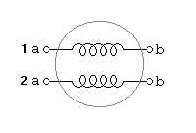
The Bipolar Controller must be able to reverse the polarity of the voltage across either coil, so current can flow in both directions. And, it must be able to energize these coils in sequence. Let us look at the mechanism for reversing the voltage across one of the coils...
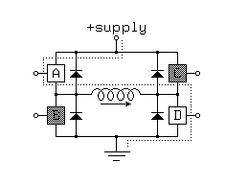
This circuit is called an H-Bridge, because it resemble a letter "H". The current can be reversed through the coil by closing the appropriate switches - AD to flow one direction then BC to flow the opposite.
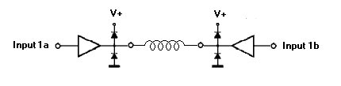
Another way of depicting the H-Bridge... Since each half of the bridge can both sink and source current, it qualifies as a push-pull type amplifier, and can be drawn with the symbol for the amplifier.
H-bridges are applicable not only to the control of stepping motors, but also to the control of DC motors, solenoids and many other applications, where polarity reversal is needed. Diodes protect the switches from the kickback of inductive type loads, such as the coils of a stepper.
Two such circuits are needed to drive both coils of the Bipolar stepper, and is commonly called a "Dual H-Bridge."
Conceptual Model of Bipolar Stepper Motor
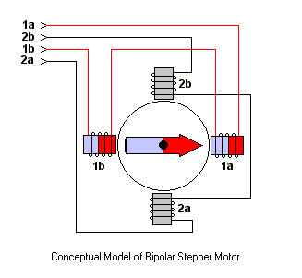
The coils are activated, in sequence, to attract the rotor, which is indicated by the arrow in the picture. (Remember that a current through a coil produces a magnetic field.) This conceptual diagram depicts a 90 degree step per phase. Assuming Terminal 1a is positive and 1b is negative, the rotor points to the East in this diagram. If these two terminals were reversed in polarity the rotor would point to the West. Coil 2 is entirely de-activated in the diagram.
In a basic "Wave Drive" clockwise sequence, winding 1 is de-activated and winding 2 activated to advance to the next phase. The rotor is guided in this manner from one winding to the next, producing a continuous cycle. Note that if two adjacent windings are activated, the rotor is attracted mid-way between the two windings.
The following table describes 3 useful stepping sequences and their relative merits. The polarity of terminals is indicated with +/-. After the last step in each sequence the sequence repeats. Stepping backwards through the sequence reverses the direction of the motor. Note that these sequences are identical to those for a Unipolar Stepper Motor.
Table of Stepping Sequences
Sequence | Polarity | Name | Description
0001  0010  0100  1000 | ---+  --+-  -+--  +--- | Wave Drive, One-Phase | Consumes the least power. Only one phase is energized at a time. Assures positional accuracy regardless of any winding imbalance in the motor.
0011  0110  1100  1001 | --++  -++-  ++--  +--+ | Hi-Torque, Two-Phase | Hi Torque - This sequence energizes two adjacent phases, which offers an improved torque-speed product and greater holding torque.
0001  0011  0010  0110  0100  1100  1000  1001 | ---+  --++  --+-  -++-  -+--  ++--  +---  +--+ | Half-Step | Half Step - Effectively doubles the stepping resolution of the motor, but the torque is not uniform for each step. (Since we are effectively switching between Wave Drive and Hi-Torque with each step, torque alternates each step.) This sequence reduces motor resonance which can sometimes cause a motor to stall at a particular resonant frequency. Note that this sequence is 8 steps.

Identifying Stepper Motors
Stepper motors have numerous wires--4,5,6, or 8. When you turn the shaft you will usually feel a "notched" movement. Motors with 4 wires require a Bipolar controller, such as the Dual H-Bridge. Others may be used with either a Unipolar or Bipolar controller. You can use an Ohm-meter to find the center tap-- the resistance between the center and a leg is 1/2 that from leg to leg. Measuring from one coil to the other will show an open circuit.
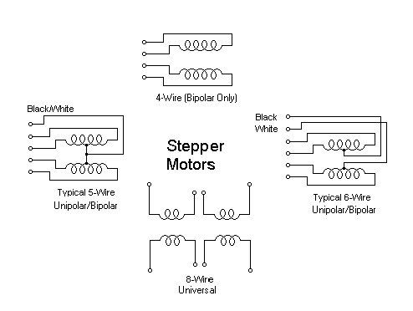
One of the benefits of the Bipolar drive circuitry is that it allows us to use both "Bipolar" and "Unipolar" motors. Bipolar motors are simply Unipolar without the center taps, which simplifies construction of the motor. So we can drive 4,6, and 8 wire steppers. Furthermore, Unipolar motors may be used in 2 different configurations-- One, simply ignore the center taps. Two, use half the coil only by using the center tap and one of the terminals. This will produce less hold torque but allows higher top speeds because of the lower inductance.
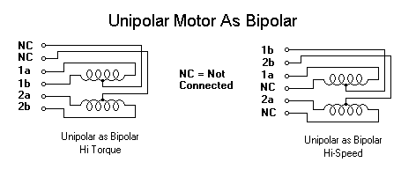

Shortcut for finding the proper wiring sequence
Connect the 4 coil wires to the controller in any pattern. If it doesn't work at first, you only need try these 2 swaps...
1 2 4 8 - (arbitrary first wiring order)
1 2 8 4 - switch end pair
1 8 2 4 - switch middle pair
You're finished when the motor turns smoothly in either direction. If the motor turns in the opposite direction from desired, reverse the wires so that ABCD would become DCBA.
Selecting a current limiting resistor
It is important that neither the motor nor controller exceed their rated currents. The value of a current-limiting resistor in series with the motor can be determined from the following equation...
Vsupply = Vdrop + (i * Rmotor) + (i * Rlimit)
Vdrop = voltage drop of Transistors used (2 volts for Unipolar, 4 volts for Bipolar Drivers)
i = current in circuit
Rmotor = resistance of single motor coil
Rlimit = current limiting power resistor
The objective is to find Rlimit that satisfies the desired current rating i
For example, Using a power supply of 12 volts, what current limiting resistor should be chosen to deliver 1 amp of current to a motor with a coil resistance of 5 ohms? Assume 2 volt drop due to the transistors.
12v = 2v + (1 amp * 5 ohm) + (1 amp * Rlimit)
12v = 2v + (5v) + (1 amp * Rlimit)
5v = 1 amp * Rlimit
Rlimit = 5v / 1 amp = 5 ohm
What will the voltage be across this resistor? 5v
What current will flow through this resistor? 1a
What power rating should this resistor be? 5v * 1a = 5 watt, minimum
This calculation is for determining the current in a single coil. Most motors and stepper circuits are rated in terms of this coil rating - amps per phase. If the hi-torque, or half-step sequence is to be used, then more than 1 coil will be activated, thus more current will be required of the power supply.
Ideally, two matched current limiting resistors should be used, one in series with each of the 2 motor coils. (The Unipolar driver can get away with sharing a single power resistor, with the center taps tied together.) Here is the configuration for the Bipolar Controller...
Current Limiting with Bipolar Controller
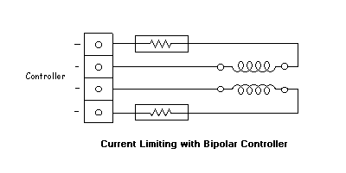
Heat Considerations
Over-heating can be an early indicator of a problem or need for additional heat sinking. This is true of both the controller and motors. Components can be warm to the touch, but not so hot that you can't leave your finger on them for a few seconds.
Motors are designed to be mounted in such a way that heat is drawn away from the motors. This is usually accomplished with a metal mounting bracket. Motors that are not yet mounted may require some type of temporary heat sinking. Motors heat more running at the LOW speeds or in Hold Mode.
If a component or motor is running too hot, try using the Wave Drive stepping mode only, if it still runs too hot, try heat sinking, and/or a fan. If it still runs too hot, something is wrong.
In summation, make your calculations carefully, and always apply caution when making any kind of modification to a circuit. Check the circuit often for over-heating.
This is the end of the Bipolar Tutorial. At this time, please refer to the documentation that accompanies your particular project for precautions and further information.
Visit the www.Stepperworld.comweb site
Stepper Motors and Control
Part I - Unipolar Stepper Motor and Control
(c) 1999 by Rustle Laidman, All Rights Reserved
Introduction
Stepper Motors have several features which distinguish them from AC Motors, and DC Servo Motors.
- Brushless - Steppers are brushless. Motors with contact brushes create sparks, undesirable in certain environments. (Space missions, for example.)
- Holding Torque - Steppers have very good low speed and holding torque. Steppers are usually rated in terms of their holding force (oz/in) and can even hold a position (to a lesser degree) without power applied, using magentic 'detent' torque.
- Open loop positioning - Perhaps the most valuable and interesting feature of a stepper is the ability to position the shaft in fine predictable increments, without need to query the motor as to its position. Steppers can run 'open-loop' without the need for any kind of encoder to determine the shaft position. Closed loop systems- systems that feed back position information, are known as servo systems. Compared to servos, steppers are very easy to control, the position of the shaft is guaranteed as long as the torque of the motor is sufficient for the load, under all its operating conditions.
- Load Independent - The rotation speed of a stepper is independent of load, provided it has sufficient torque to overcome slipping. The higher rpm a stepper motor is driven, the more torque it needs, so all steppers eventually poop out at some rpm and start slipping. Slipping is usually a disaster for steppers, because the position of the shaft becomes unknown. For this reason, software usually keeps the stepping rate within a maximum top rate. In applications where a known RPM is needed under a varying load, steppers can be very handy.
Types of steppers
Stepper Motors come in a variety of sizes, and strengths, from tiny floppy disk motors, to huge machinery steppers rated over 1000 oz in. There are two basic types of steppers-- bipolar and unipolar. The bipolar stepper has 4 wires. Unipolar steppers have 5,6 or 8 wires. This document will discuss control of Unipolar Steppers.
Motor Basics
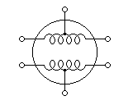
The Unipolar Stepper motor has 2 coils, simple lengths of wound wire. The coils are identical and are not electrically connected. Each coil has a center tap - a wire coming out from the coil that is midway in length between its two terminals. You can identify the separate coils by touching the terminal wires together-- If the terminals of a coil are connected, the shaft becomes harder to turn. Because of the long length of the wound wire, it has a significant resistance (and inductance). You can identify the center tap by measuring resistance with a suitable ohm-meter (capable of measuring low resistance <10 ohm) The resistance from a terminal to the center tap is half the resistance from the two terminals of a coil. Coil resistance of half a coil is usually stamped on the motor; for example, '5 ohms/phase' indicates the resistance from center tap to either terminal of a coil. The resistance from terminal to terminal should be 10 ohms.
Motor Control Circuitry
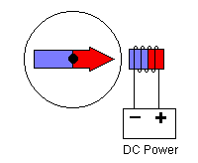
Current flowing through a coil produces a magnet field which attracts a permanent magnet rotor which is connected to the shaft of the motor. The basic principle of stepper control is to reverse the direction of current through the 2 coils of a stepper motor, in sequence, in order to influence the rotor. Since there are 2 coils and 2 directions, that gives us a possible 4-phase sequence. All we need to do is get the sequencing right and the motor will turn continuously. You may wonder how the stepper can achieve such fine stepping increments with only a 4-phase sequence. The internal arrangement of the motor is quite complex- the winding and core repeating around the perimeter of the motor many times. The rotor is advanced only a small angle, either forward or reverse, and the 4-phase sequence is repeated many times before a complete revolution occurs.
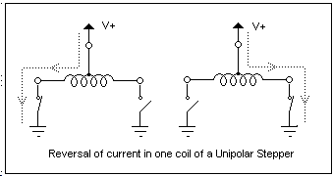
Let us return to the 4-phase sequence of reversing the current though the 2 coils. A Bipolar stepper controller achieves the current reversal by reversing the polarity at the two terminals of a coil. The Unipolar controller takes advantage of the center tap to achieve the current reversal with a clever trick -- The center tap is tied to the positive supply, and one of the 2 terminals is grounded to get the current flowing one direction. The other terminal is grounded to reverse the current. Current can thus flow in both directions, but only half coils are energized at a time. Both terminals are never grounded at the same time, which would energize both coils, achieving nothing but a waste of power.
Conceptual Model of Unipolar Stepper Motor
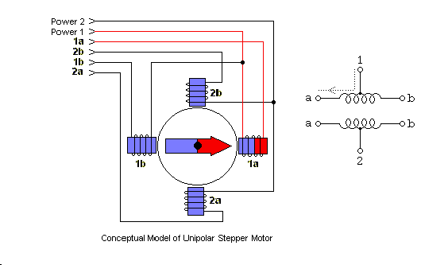
With center taps of the windings wired to the positive supply, the terminals of each winding are grounded, in sequence, to attract the rotor, which is indicated by the arrow in the picture. (Remember that a current through a coil produces a magnetic field.) This conceptual diagram depicts a 90 degree step per phase.
In a basic "Wave Drive" clockwise sequence, winding 1a is de-activated and winding 2a activated to advance to the next phase. The rotor is guided in this manner from one winding to the next, producing a continuous cycle. Note that if two adjacent windings are activated, the rotor is attracted mid-way between the two windings.
The following table describes 3 useful stepping sequences and their relative merits. The sequence pattern is represented with 4 bits, a '1' indicates an energized winding. After the last step in each sequence the sequence repeats. Stepping backwards through the sequence reverses the direction of the motor.
Table of Stepping Sequences
Sequence | Name | Description
0001  0010  0100  1000 | Wave Drive, One-Phase | Consumes the least power. Only one phase is energized at a time. Assures positional accuracy regardless of any winding imbalance in the motor.
0011  0110  1100  1001 | Hi-Torque, Two-Phase | Hi Torque - This sequence energizes two adjacent phases, which offers an improved torque-speed product and greater holding torque.
0001  0011  0010  0110  0100  1100  1000  1001 | Half-Step | Half Step - Effectively doubles the stepping resolution of the motor, but the torque is not uniform for each step. (Since we are effectively switching between Wave Drive and Hi-Torque with each step, torque alternates each step.) This sequence reduces motor resonance which can sometimes cause a motor to stall at a particular resonant frequency. Note that this sequence is 8 steps.

Identifying Stepper Motors
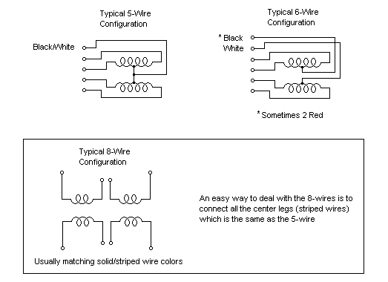
Stepper motors have numerous wires, 4, 5, 6, or 8. When you turn the shaft you will usually feel a "notched" movement. Motors with 4 wires are probably Bipolar motors and will not work with a Unipolar control circuit. The most common configurations are pictured above. You can use an ohm-meter to find the center tap - the resistance between the center and a leg is 1/2 that from leg to leg. Measuring from one coil to the other will show an open circuit, since the 2 coils are not connected. (Notice that if you touch all the wires together, with power off, the shaft is difficult to turn!)
Shortcut for finding the proper wiring sequence
Connect the center tap(s) to the power source (or current-Limiting resistor.) Connect the remaining 4 wires in any pattern. If it doesn't work, you only need try these 2 swaps...
1 2 4 8 - (arbitrary first wiring order)
1 2 8 4 - switch end pair
1 8 2 4 - switch middle pair
You're finished when the motor turns smoothly in either direction. If the motor turns in the opposite direction from desired, reverse the wires so that ABCD would become DCBA.
Stepper Motor Ratings
Manufacturers rate stepper motors with at least two of the familiar electrical terms: voltage, current, resistance. When one of these terms is missing it can be derived using the formula: Voltage = Current x Resistance. If only the current rating is known, the resistance rating can be found by carefully measuring a half coil (center-tap to either terminal) with an ohmmeter.
In the rating nomenclature, a 'phase' refers to the minimum operational coil, which is a half-coil for unipolar motors. For example, '5 ohms/phase' indicates the half-coil resistance. A current rating (i.e. 2 amps/phase) specifies the maxium current the motor can sustain through a half-coil for an extended period without overheating.
The current rating is usually taken as the ideal operating current.
Selecting a current limiting resistor
It is important that neither the motor nor controller exceed their rated currents. There is a precise relationship between the Voltage, Resistance, and Current ratings of both the motor and controller which must be understood before experimenting with motors.
The most straightforward way of reducing current to a motor is to reduce the voltage. With power supplied to the motor at its rated voltage, calculations are easy-- the motor will draw the rated current.
There may be times, however, when the rated motor voltage is not available and you need to reduce current to the motor, or you simply wish to run the motors below the rated current. (There is a benefit of running motors at much higher than rated voltages with proper current-limiting -- the motors can achieve higher RPMs.)
A current-limiting resistor in series with the motor can be used to effectively limit current to the motor, at the cost of wasted power. The resistor used is a special "power resistor" which must dissipate heat. Ideally, the resistor should be a non-inductive type so as not to interfere with the inductance of the motor and control circuit (especially when current-limiting to achieve higher RPMs).
The value of a current-limiting resistor in series with a motor coil can be derived from the following equality...
Vresistor = (Vsupply - Vmotor - Vdrop) = IR
Where...
Vsupply = Power supply voltage
Vmotor = Motor voltage rating
Vresistor = Voltage developed across the power resistor
Vdrop = Voltage drop due to transistors (0v for FETs, 1-2v otherwise)
Vmotor and I are fixed attributes of the motor. R is selected based on the power supply voltage that will be used. (This resistor also has a power rating.)
First, calculate Vresistor...
Vresistor = Vsupply - Vmotor - Vdrop
Then solve for R based on the desired current...
R = Vresistor / I
Minimum resistor wattage = Vresistor * I
For example, Using a power supply of 12 volts, what current limiting resistor should be chosen to deliver 1 amp of current to a motor with a voltage rating of 5v? Assume 1 volt drop due to the transistors used.
Vresistor = (12v - 5v - 1v) = 6v
R = 6V / 1 amp = 6 ohm
What will the voltage be across this resistor? 6v
What current will flow through this resistor? (same as motors current rating) = 1a
What power rating should this resistor be? 6v * 1a = 6 watt, minimum.
In practice, the wattage rating of the power resistor should be at least twice the calculated minimum. In addition, heat sinking may be required for power resistors.
Ideally, two matched current limiting resistors should be used, one in series with each of the 2 motor coil center taps.
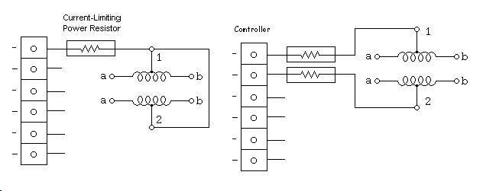
The unipolar driver can share a single power resistor when the motor center taps are tied together, as in the 5-wire configuration. This single resistor can be thought of as two calculated resistors with terminals shorted, so they operate in parallel. The value of the single resistor is then half the calculated ohm value, with twice the calculated wattage rating. This works best in HI-Torque mode.
Power Supply Considerations
The current drawn by a single motor, holding in Hi-Torque mode is twice the rated current. Therefore the power supply must have a current rating of at least twice the motor current rating times the number of motors. This current requirement is the same regardless of operating voltage. (Don't forget the power resistors when the power supply voltage exceeds the motor voltage.)
In summation, make your calculations carefully, and always apply caution when making any kind of modification to a circuit. Check the circuit often for over-heating.
Heat Considerations
Over-heating can be an early indicator of a problem or need for additional heat sinking. This is true of both the controller and motors. Components can be warm, even hot to the touch, but not so hot that you can't leave your finger on them for a few seconds.
Motors are designed to be mounted in such a way that heat is drawn away from the motors. This is usually accomplished with a metal mounting bracket. Motors that are not yet mounted may require some type of temporary heat sinking. Motors heat more running at the LOW speeds or in Hold Mode.
If a component or motor is running too hot, try using the Wave Drive stepping mode only, if it still runs too hot, try heat sinking, and/or a fan. If it still runs too hot, something is wrong.
This is the end of the Unipolar Stepper Motor Tutorial. At this time, please refer to the documentation that accompanies your particular project for precautions and further information.
Stepper Motors and Control
Part II - Bipolar Stepper Motor and Control
(c) 1999 by Rustle Laidman, All Rights Reserved
Introduction
The Bipolar Stepper motor is very similar to the Unipolar Stepper discussed in part I of this Tutorial, except that the motor coils lack center taps. Because of this, the Bipolar motor requires a different type of controller, one that reverses the current flow through the coils by alternating polarity of the terminals, giving us the name - Bipolar. A Bipolar motor is capable of higher torque since entire coil(s) may be energized, not just half-coils. Where 4-wire steppers are strictly 'Bipolar', 5 and 6 wire motors with center-taps can be used with the Bipolar controller.
Bipolar Basics
The Bipolar Stepper motor has 2 coils. The coils are identical and are not electrically connected. You can identify the separate coils by touching the terminal wires together-- If the terminals of a coil are connected, the shaft becomes harder to turn.
The Bipolar Controller must be able to reverse the polarity of the voltage across either coil, so current can flow in both directions. And, it must be able to energize these coils in sequence. Let us look at the mechanism for reversing the voltage across one of the coils...
This circuit is called an H-Bridge, because it resemble a letter "H". The current can be reversed through the coil by closing the appropriate switches - AD to flow one direction then BC to flow the opposite.
Another way of depicting the H-Bridge... Since each half of the bridge can both sink and source current, it qualifies as a push-pull type amplifier, and can be drawn with the symbol for the amplifier.
H-bridges are applicable not only to the control of stepping motors, but also to the control of DC motors, solenoids and many other applications, where polarity reversal is needed. Diodes protect the switches from the kickback of inductive type loads, such as the coils of a stepper.
Two such circuits are needed to drive both coils of the Bipolar stepper, and is commonly called a "Dual H-Bridge."
Conceptual Model of Bipolar Stepper Motor
The coils are activated, in sequence, to attract the rotor, which is indicated by the arrow in the picture. (Remember that a current through a coil produces a magnetic field.) This conceptual diagram depicts a 90 degree step per phase. Assuming Terminal 1a is positive and 1b is negative, the rotor points to the East in this diagram. If these two terminals were reversed in polarity the rotor would point to the West. Coil 2 is entirely de-activated in the diagram.
In a basic "Wave Drive" clockwise sequence, winding 1 is de-activated and winding 2 activated to advance to the next phase. The rotor is guided in this manner from one winding to the next, producing a continuous cycle. Note that if two adjacent windings are activated, the rotor is attracted mid-way between the two windings.
The following table describes 3 useful stepping sequences and their relative merits. The polarity of terminals is indicated with +/-. After the last step in each sequence the sequence repeats. Stepping backwards through the sequence reverses the direction of the motor. Note that these sequences are identical to those for a Unipolar Stepper Motor.
Table of Stepping Sequences
Sequence | Polarity | Name | Description
0001  0010  0100  1000 | ---+  --+-  -+--  +--- | Wave Drive, One-Phase | Consumes the least power. Only one phase is energized at a time. Assures positional accuracy regardless of any winding imbalance in the motor.
0011  0110  1100  1001 | --++  -++-  ++--  +--+ | Hi-Torque, Two-Phase | Hi Torque - This sequence energizes two adjacent phases, which offers an improved torque-speed product and greater holding torque.
0001  0011  0010  0110  0100  1100  1000  1001 | ---+  --++  --+-  -++-  -+--  ++--  +---  +--+ | Half-Step | Half Step - Effectively doubles the stepping resolution of the motor, but the torque is not uniform for each step. (Since we are effectively switching between Wave Drive and Hi-Torque with each step, torque alternates each step.) This sequence reduces motor resonance which can sometimes cause a motor to stall at a particular resonant frequency. Note that this sequence is 8 steps.

Identifying Stepper Motors
Stepper motors have numerous wires--4,5,6, or 8. When you turn the shaft you will usually feel a "notched" movement. Motors with 4 wires require a Bipolar controller, such as the Dual H-Bridge. Others may be used with either a Unipolar or Bipolar controller. You can use an Ohm-meter to find the center tap-- the resistance between the center and a leg is 1/2 that from leg to leg. Measuring from one coil to the other will show an open circuit.
One of the benefits of the Bipolar drive circuitry is that it allows us to use both "Bipolar" and "Unipolar" motors. Bipolar motors are simply Unipolar without the center taps, which simplifies construction of the motor. So we can drive 4,6, and 8 wire steppers. Furthermore, Unipolar motors may be used in 2 different configurations-- One, simply ignore the center taps. Two, use half the coil only by using the center tap and one of the terminals. This will produce less hold torque but allows higher top speeds because of the lower inductance.

Shortcut for finding the proper wiring sequence
Connect the 4 coil wires to the controller in any pattern. If it doesn't work at first, you only need try these 2 swaps...
1 2 4 8 - (arbitrary first wiring order)
1 2 8 4 - switch end pair
1 8 2 4 - switch middle pair
You're finished when the motor turns smoothly in either direction. If the motor turns in the opposite direction from desired, reverse the wires so that ABCD would become DCBA.
Selecting a current limiting resistor
It is important that neither the motor nor controller exceed their rated currents. The value of a current-limiting resistor in series with the motor can be determined from the following equation...
Vsupply = Vdrop + (i * Rmotor) + (i * Rlimit)
Vdrop = voltage drop of Transistors used (2 volts for Unipolar, 4 volts for Bipolar Drivers)
i = current in circuit
Rmotor = resistance of single motor coil
Rlimit = current limiting power resistor
The objective is to find Rlimit that satisfies the desired current rating i
For example, Using a power supply of 12 volts, what current limiting resistor should be chosen to deliver 1 amp of current to a motor with a coil resistance of 5 ohms? Assume 2 volt drop due to the transistors.
12v = 2v + (1 amp * 5 ohm) + (1 amp * Rlimit)
12v = 2v + (5v) + (1 amp * Rlimit)
5v = 1 amp * Rlimit
Rlimit = 5v / 1 amp = 5 ohm
What will the voltage be across this resistor? 5v
What current will flow through this resistor? 1a
What power rating should this resistor be? 5v * 1a = 5 watt, minimum
This calculation is for determining the current in a single coil. Most motors and stepper circuits are rated in terms of this coil rating - amps per phase. If the hi-torque, or half-step sequence is to be used, then more than 1 coil will be activated, thus more current will be required of the power supply.
Ideally, two matched current limiting resistors should be used, one in series with each of the 2 motor coils. (The Unipolar driver can get away with sharing a single power resistor, with the center taps tied together.) Here is the configuration for the Bipolar Controller...
Current Limiting with Bipolar Controller
Heat Considerations
Over-heating can be an early indicator of a problem or need for additional heat sinking. This is true of both the controller and motors. Components can be warm to the touch, but not so hot that you can't leave your finger on them for a few seconds.
Motors are designed to be mounted in such a way that heat is drawn away from the motors. This is usually accomplished with a metal mounting bracket. Motors that are not yet mounted may require some type of temporary heat sinking. Motors heat more running at the LOW speeds or in Hold Mode.
If a component or motor is running too hot, try using the Wave Drive stepping mode only, if it still runs too hot, try heat sinking, and/or a fan. If it still runs too hot, something is wrong.
In summation, make your calculations carefully, and always apply caution when making any kind of modification to a circuit. Check the circuit often for over-heating.
This is the end of the Bipolar Tutorial. At this time, please refer to the documentation that accompanies your particular project for precautions and further information.
Stepper Motors and Control
Part III - Current Control of Stepper Motors
(c) 1999 by Rustle Laidman, All Rights Reserved
Introduction
Before reading this Tutorial, the reader should first review the Unipolar and Bipolar Stepper Tutorials. With a grasp of basic Stepper control, you are now ready to tackle the more sophisticated aspect of stepper theory: Current Control.
There are several reasons for implementing current control...
- Avoid Overheating
- Accommodate a variety of Motors
- Increase Torque at higher speed
- Increase Top Speed
- Improve Power Efficiency (with Chopper style circuit)
In its simplest configuration, a stepper motor draws its rated current when connected to its rated voltage. The purpose of this 'rating' is to give the circuit designer guidance as to when the motor will over-heat. ie. How much current can continuously run through the windings without overheating the motor. A motor should not over-heat (when appropriately mounted) if connected to its rated voltage. Of course over-heating is what we strive to avoid, since it adversely effects the performance of the motor and even presents serious safety issues.
However, the exact operating voltage of a particular motor may not be available and, as we will see, it may be desirable to drive a motor from a supply voltage higher than the rated voltage (with proper current limiting). You can always drive a stepper with less than the rated voltage, the motor will simply run at less than its full torque capability.
When the operating voltage is higher than the voltage rating of the motor, the simplest way of limiting the current through the motors windings, thus staying within the safe operating range of the motor, is with a current limiting resistor. (Drivers that employ this method of current reduction are known as L/R drivers, L=Inductance, R=Resistance) This resistor, placed in series with the winding diverts some current from the winding and dissipates it in the form of heat.
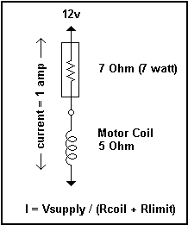
The voltages and current in this simple circuit can be analyzed as a simple resistive voltage divider. It is important to note that because of the small resistances we're talking about here (1 to 20 ohms) a special type of resistor is needed, called a 'power' resistor. Power is expressed as Watts = Volts * Amps, and a little calculation shows that the resistor needed can easily exceed 10 watts, which translates into a lot of heat! (You should not experiment with current limiting resistors without understanding of the concept of power.)
One can devise other ways to reduce the current, with transistors instead of a resistor, but you will face the same heat dissipation problem. When you attempt to linearly regulate the current flow within a circuit, you will always face a heat problem. Fortunately there is a technique, known as 'Chopping' , which can limit the current in the winding without generating excess heat. It is quite elegant and efficient. The essence of chopping is to switch the operating voltage on and off at a frequency higher than the operating range, and allow the motor itself to act as a filter, You may be familiar with this concept through Pulse-width modulation, in which the 'duty cycle' (percentage of on time) determines the behavior of the motor or whatever is being controlled. One common application of this type of circuit is the electronic light dimmer switch.
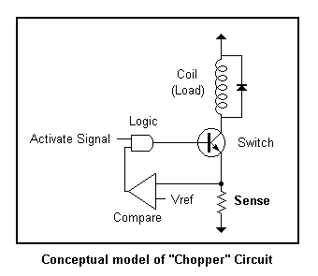
Now let's look at a conceptual model of a "Chopper" circuit. When an incoming "activate" signal is received, the load (our stepper coil) is switched on. Current through the coil is developed as a voltage across a "sense" resistor. This voltage is proportional to the amount of current in the coil and forms an important part of our feedback sensor. The value of this resistor is very low, typically 1 ohm, which equates to 1 amp, when the voltage at the sense resistor is 1 volt.) The sensed voltage is compared with a reference voltage, and when the sensed voltage becomes greater than the reference the logic switches the coil off. When the voltage drops below the reference voltage the coil is switched back on, unless of course the incoming activate signal is removed, in which case the coil is always off. Thus the feedback logic flips the switch on and off when the current is too high or to low, maintaining a constant amount of current. The reference voltage is typically adjustable which allows us to match the current in the circuit to the motors rated current.
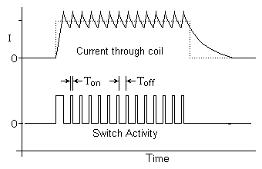
If we were to look at the waveforms of the chopper circuit we would see the current through the coil (top waveform) increase and then sawtooth about the desired current setting (as determined by the reference voltage.) The waveform below indicates the switch activity logic turning the coil on and off at high frequency (typically 20Khz for stepper circuits.)
Now let us look at the ways in which the stepper benefits by using this current control method.
Accommodate a variety of Motors
The reference voltage in the feedback circuit described above is usually adjustable and provides a mechanism for regulating the amount of current in the coil(s) of our stepper motor. The reference voltage is typically set with a potentiometer or a single resistor. The supply voltage in a chopper design should be at least twice the rated voltage of the motor, in order to allow the switching action to occur. If the supply voltage were equal to (or less than) the motor voltage no chopping action can occur (at full rated current), since the current would never exceed the rated current. In fact, as the motor turns faster the current in the motor drops and we lose the current regulating effect. So, in addition to 'limiting' the current, a chopping circuit actually helps maintain a constant amount of current, independent of load and motor speed.
Increase Top Speed
Let us now look at an important reason for current limiting - to increase the top speed of the motor. The coils in a stepper are inductors - when you apply a voltage, it takes time for the current level to increase. This is very much like feeding a square wave through a low pass filter - the current increases and decreases in a logarithmic fashion. The rise and fall time in reaction to an input step waveform is known as the 'slew rate'. It takes time for the current to 'slew' from one level to another. When the step frequency is low, this logarithmic slope doesn't affect the performance of the motor, since there is plenty of time for the current to reach full level relative to the step rate. However as the step rate approaches the time it takes for the current to ramp up, it begins to have an effect on the motor performance. The current does not have enough time to reach full value before the next step reverses the current flow. This is illustrated in the graph below.
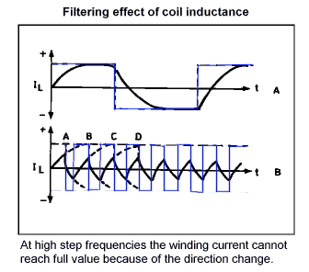
As you can see, when the step frequency is low (A) the current has time to reach full, ideal level. But, as the step frequency increases the current cannot reach full level, before it must reverse direction. The resultant waveform (B) is a wimpy, under-performing version of what we want, that gets worse and worse as the step frequency increases. In terms of motor performance, the motor loses power the faster we step until eventually there's not enough power to keep the motor spinning.
The solution to getting a better slew rate (a current waveform with sharper attack) is to increase the supply voltage. This decreases the time necessary to charge to full level, resulting in a 'squarer' looking waveform. However, now there's a problem which must be addressed - we will have too much current in the circuit. This current MUST be limited. We want the better slew rate without over-heating the motor. There are 2 solutions and their effect can be seen in the graph below.
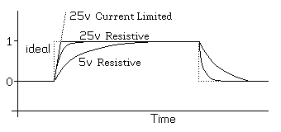
The Square wave is the 'ideal' waveform. The 5v resistive waveform is what we get with a 5v motor running at 5v. We can improve the slew rate by adding a current limiting resistor in series with the motor and increase the voltage to 25v, as seen in the 25v resistive waveform. But the best performance is obtained with our chopping (Current Limited) circuit which can turn on the current with the sharpest attack and simply switch it on and off to maintain this level.
It is very important to note that the 25v resistive method has some serious implementation issues. First, you should use a non-inductive resistor. Many power resistors are wirewound, which have inductance of their own, and this brings the problem right back! It's like putting another coil in series with the coil, the current is reduced but the inductance is increased with little or no improvement in the slew rate. Second, the there are some serious power issues if you were to attempt to limit a 5v motor to be powered from a 25v power source. 4/5 of the power would have to go into the current limiting resistor! This is a tremendous waste of power, not to mention all the heat that must be dissipated. Also, the current limiting resistor would be physically large with a large power rating, greater than 20 watts. Clearly, the best solution is our chopping circuit. The chopper circuit offers not only the best performance, but is also the most efficient!
Summary
In summary, current control offers several advantages-- It can accommodate a variety of motors with a simple adjustment to set the current. The top speed of the motors is increased with the Chopping Current control method, which uses a high voltage to achieve current waveforms with quick rise times. The torque curve of the motor is smoothed out over operating range of the motor speeds because the current, rather than voltage, is maintained at a constant level. And of course, we achieve power efficiency by not generating excess heat in order to achieve these desirable characteristics. Steppers have been around many years. Chopping current control is fairly new for Stepper Motor control, and offers many improvements over the old L/R type drivers.
This is the end of the Current Control Tutorial. At this time, please refer to the documentation that accompanies your particular project for precautions and more information.
Stepper Motors and Control
Part IV - Microstepping of Stepper Motors
(c) 1999 by Rustle Laidman, All Rights Reserved
The ideal current waveform for driving a stepper motor is a Sinewave.
Two sinewaves in 'quadrature' (90 degrees out of phase) form the ideal current drive. If the two stepper coils follow the current waveforms depicted in diagram 1, the motor will run quietly and smoothly, the ideal condition. In fact, the "step" usually associated with stepper motors will disappear.
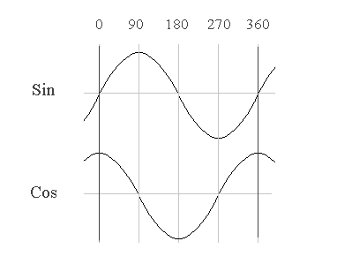
diagram 1
Let us look at why this is. The sine/cosine waves allow the motor to transition continuously from one pole (whole step position) to the next. As one coil increases in current the other decreases; the rotor advances smoothly and torque output is continuous at any given position. The torque (power) stays the same for any angle because the current is always correctly proportioned between the 2 coils. (Power is calculated as the square root of the sum of the squares of current in each coil. From trigonometry we know that sin^2 + cos^2 = 1, so the sum of the squares is constant.) The motor shaft advances smoothly during the entire cycle.
Now, let's compare this with current waveforms of the typical Bipolar stepper driver (in Hi-Torque mode).
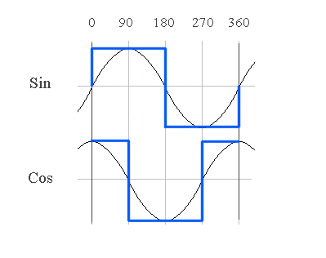
diagram 2
This is obviously not sinusoidal. There are no smooth transitions. However, this is still useful for typical stepper applications which only need to step the motor in full steps, where the motor can (to a lesser degree) hold its position without current applied, using detent magnetic torque. The stepper driver attempts quantum leaps between coil states which correspond to the motors natural full-step positions.
However, let's look at a real-world example of a coil excited by a square wave voltage; the resultant current waveform is more like what you see in diagram 3, with current overshoot and ringing which can occur at 'natural' frequencies of the motor and/or mechanical system to which it is attached. This phenomenon is known as "resonance" and can be a very real problem in mechanical systems. Microstepping helps reduce resonance problems because it doesn't allow the current levels to get 'out of control' like this. Clearly, the sinusoidal waveforms of diagram 1 are preferable. What type of controller can we use to control the current in the motor coils in this manner?
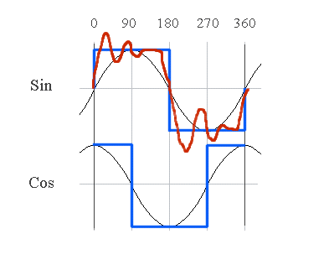
diagram 3
Recall the chopping current-control model from our Tutorial on Current-limiting. If we add a DAC (digital-to-analog converter) to the circuit and use it as the voltage reference, we can digitally set the reference voltage and thus regulate the current through the coil, in discrete steps. (The current in the coil is developed as a voltage across the sense resistor.) Discrete steps are not quite as good as a smooth Sinewave, but if the steps are small enough the waveform approaches a sinewave.
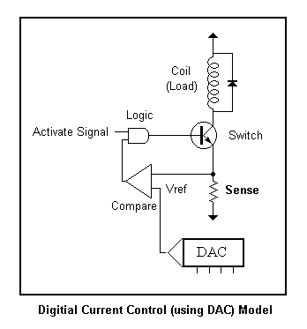
A controller that can generate fractional steps using this method of current regulation is called a Microstepping driver. A Microstepping driver can sub-divide the motors step angle into many subdivisions (4 or more) Below is a representation of the Microstepping driver (1/2 of the circuit is shown)-- a chopping H-Bridge with digital current control. This circuit controls one coil of the stepper motor. An identical circuit controls the other coil, the current direction and current levels are synchronized to create the desired sine/cos quadrature waveforms. The voltage waveform at the sense resistor is a rectified sinewave (absolute value of sinewave), since current never goes negative in the sense resistor. (Recall how the H-Bridge reverses the direction of current in the coil.) It is usually convenient to look at the voltage level at the sense resistor if you want to see the current waveform.
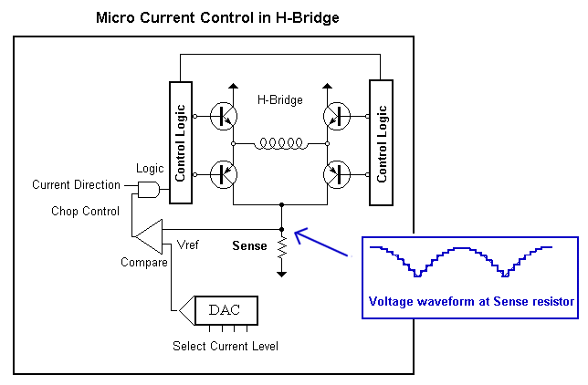
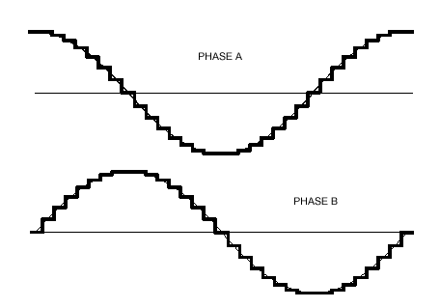
Phasor Diagrams
Let's now look at what current ratios are needed to produce a particular step angle. The Microstep angle can be graphically represented with a Phasor Diagram. (See diagram below) The X and Y axis indicate the current level in two respective coils A, B. A vector (ray from origin to coordinate X,Y) shows the resultant angle and Torque (magnitude of the vector) when some current is applied to both coils. Keep in mind that this diagram shows the 'sub-angle' between natural whole steps (poles) of the motors. On a typical 200 step per revolution motor this is 1.8 degrees. The graph below is a representation of how that angle can be further sub-divided.
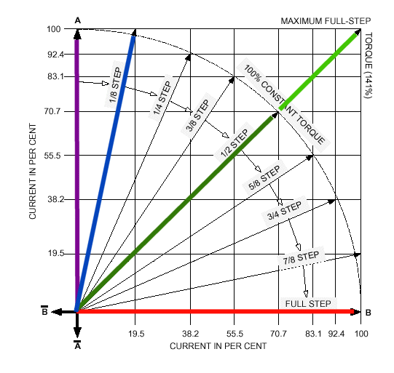
Try to locate the following Vectors and understand what it represents:
RED
Full current to coil B, only. Rotor points to a natural 'pole' at a whole step position.
PURPLE
Full current to coil A, only. Rotor points to a natural 'pole' also at a whole step position.
GREEN(LIGHT GREEN)
The green vectors are the most important to grasp. The light green vector shows what happens when you take a 'half' step with an ordinary (non-microstepping) controller by fully activating both coils. The angle is correct, since rotor points midway between the natural poles, but the magnitude (torque) is greater than at the whole step positions (Red and Purple vectors.) The magnitude is 1.414 times (square root of two) greater. The result is uneven torque, with resultant surges in current usage with each half step.
GREEN(DARK GREEN)
Now consider the Dark Green Vector. The angle is the same as the light green (rotor points midway between the natural poles) but the torque is now the same magnitude as the whole step positions. This was achieved by reducing the current by .707 (one half the square root of 2) in each coil. The result is even torque at the half step positions, precisely what we want.
BLUE
Now carry this concept one step further and look at the blue (1/8 step) vector. The current in the coils is precisely proportioned to achieve an eighth step between the whole step positions, with equivalent torque. You can tell that the torque is equivalent since the magnitude (length) of this ray is the same as the whole step vectors. All the microstep vectors have the same magnitude!
Once you understand the phasor diagram, you can see how the Microstepping controller uses the current levels in each of the 2 coils to achieve the desired sub-angle. What are the limits? How small a step angle can you take? This depends on the precision of the motor and the Microstep driver. Generally speaking, 1/8th to 1/16th step is a good compromise that can be achieved with ordinary motors and a good controller. Let's look at the current ratios needed to achieve a particular 1/8 step angle.
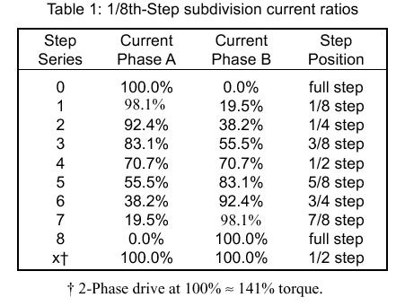
These are some pretty precise numbers. It takes a 5 bit linear DAC to get within 3% of these sinusoidal values. In order to reduce the number of control lines, some manufacturers (Allegro) use a non-linear DAC which is 'sine-weighted' to these percentages: 0, 19.5, 38.2, 55.5, 70.7 , 83.1, 92.4, [98.1], 100. Now all the percentages can be represented with only 3 bits. In practice, the 98.1% value is thrown out and rounded to 100% in order to fit the 9 values in 3 bits (8 values). This is a reasonable compromise.
Current Decay - Recirculation Modes
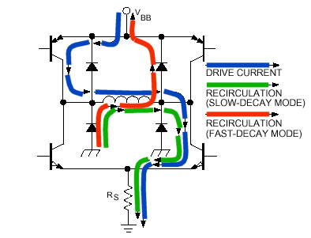
We now come to one of the most advanced topics in all of Stepper motor theory - Current Recirculation. This subject separates the men from the boys when it comes to manufacturers of Microstepping circuitry. Some choose to ignore it completely, some give you complete control. Personally, I consider Allegro's understanding and handling of this topic to be top-notch. But first, what is Current Decay? (Note: this topic also has relevance in non-Microstepping Controllers but will not be discussed here.)
Recall that the chopping current driver turns the H-Bridge sections on and off to energize the motor coil. This is shown as the blue path in the diagram above. When the appropriate transistors are activated current flows through the coil in the desired direction (blue path). Now, when the current gets too great, (as developed across the sense resistor at the bottom) the chopping driver turns the coil off, in order to regulate the current. (BTW - All kinds of wonderful things happen when you switch coils on and off.) Where should the current go? What path should be provided for the current to decay? We need to know this in order to determine which transistors to open/close during the decay phase of current regulation. The green path provides for a slow decay, the red path allows a fast decay. Which is appropriate? That depends on on the rate that the motor is spinning and where we are in the sinusoidal curve. The objective is to follow the sinewave as close as possible. When the sinewave is at a peak, the rate of change is 0, therefore the decay should be slow, but when it crosses zero it should be faster. Depending on the frequency of the sinewave, the rate of decay could be anything! What should we do, and how will our decision effect motor performance?
In general, slow decay makes for quieter operation. But if the decay is too slow we lose Sine tracking and could run into resonance problems. When the decay is too fast, the motor is noisy and the efficiency of the chopper is decreased since it's switching more often in order to regulate the current.
What is the solution? Allegro offers a choice of Slow, Fast, and Mixed decay modes. The percentage fast decay ratio (PFD) in 'Mixed' mode is even adjustable. But, this is a static solution that does not take into account motor speed. The best solution is a dynamic method, in which the decay mode tracks the current rate of change of the Sinewave. This allows the most precise tracking, and involves the least amount of "tuning" to a particular motor. It is somewhat tricky to implement, however. The decay "trajectory" must be modified each quadrant, and must actually be inverted depending on which direction the motor is spinning! (I call this method 'Dynamic' in my Microstepping Controllers.) But that is enough of stepper theory for now. If you followed me thus far, you can probably get a job at Allegro!
This is the end of the Current Control Tutorial. At this time, please refer to the documentation that accompanies your particular project for precautions and further information.
Hi Rustle!
Here are a few of the photos I promised you. Hope they are what you needed.
As you can see, my setup is organized on a PC cart so it can be moved about
easily. Sliding shelves provide easy access to the controller components
and the PC. I usually keep it in the garage. It connects to a ShopVac
vacuum cleaner for dust-free operation.
I do the actual image work on a workstation in our computer room. After
resizing and adjusting the contrast to the greyscale images, the files are
converted to ISO g-codes and then sent over a home network to the computer
that runs the CNC in the garage.
The SP-3/HT controller board is mounted directly to the power supply and the
power resistors are also attached via a heatsink made with aluminum channel.
Everything runs very smoothly and stays cool even after hours of use. The
added torque of the SP-3/HT and your excellent stepping motors provide
plenty of power and remarkable stability to the system. In fact, it's so
powerful that I'm considering replacing the Dremel with a 7/8 hp trim router
so I can speed up the carving process even more.
I'm very happy with your SP-3/HT system. It is a top quality product that
has given me a great improvement over my previous setup.
Keep up the great work!
Rod McClure
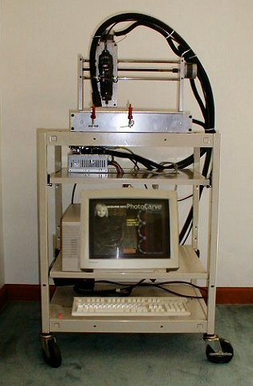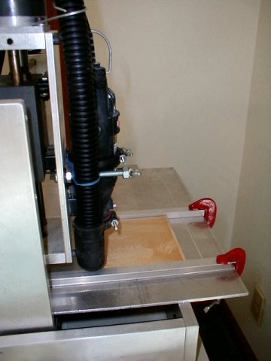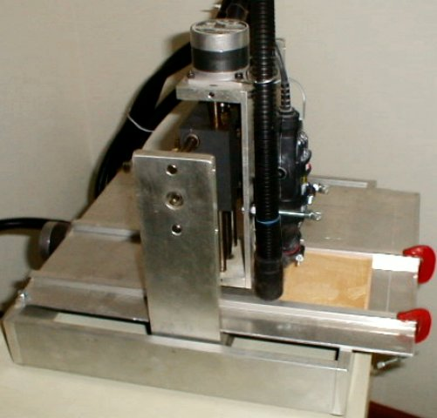
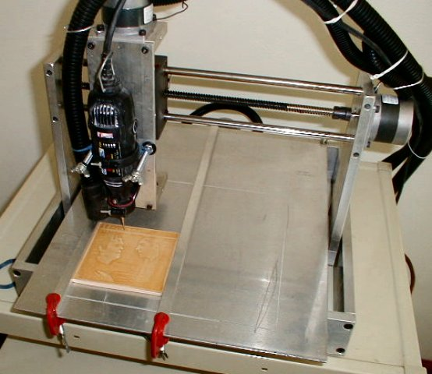
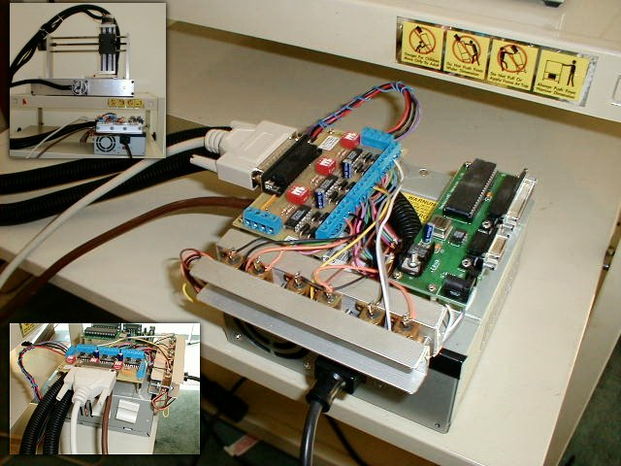
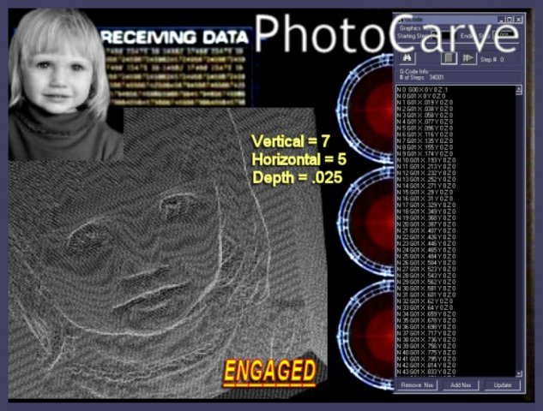
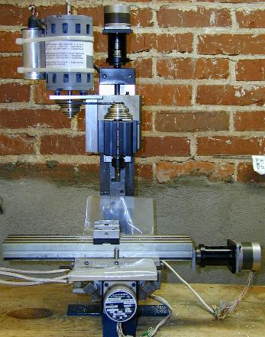

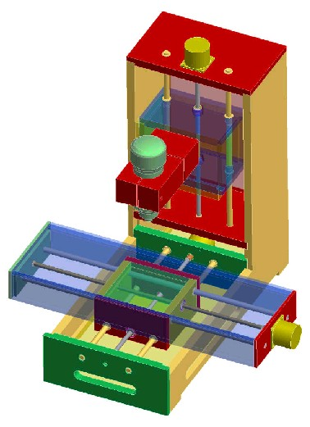

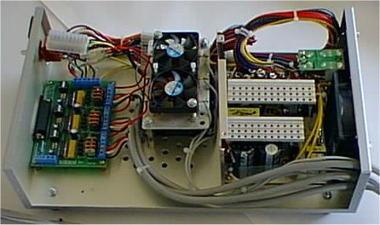
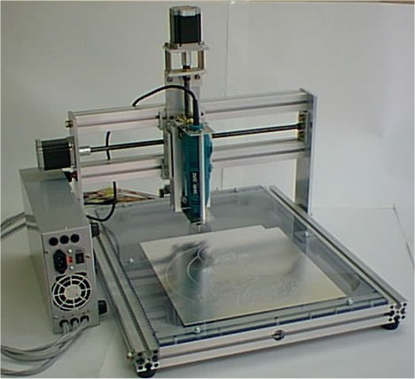
Russ,
Have a peek at the machine I built and the clock I cut. Your FET3 and motors are working great on 27 volts and 3, 7.5 ohm resistors for 48" per minute. Thanks for the help.
Clock plans were downloaded free from www.woodenclocks.co.uk
Eric
E-Z FLIGHT MODEL KITS
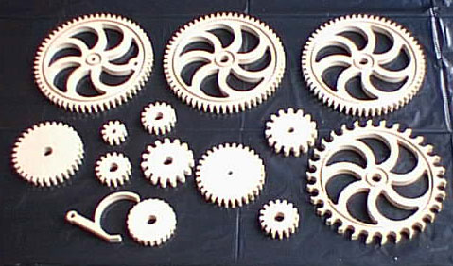
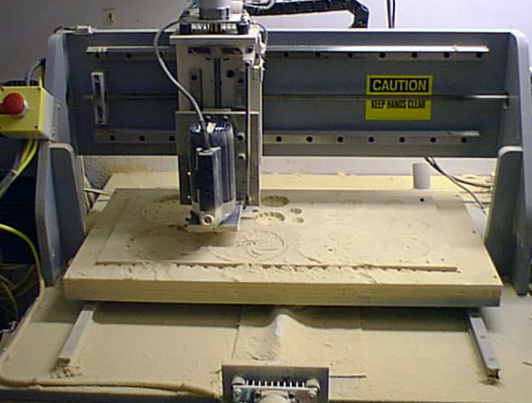
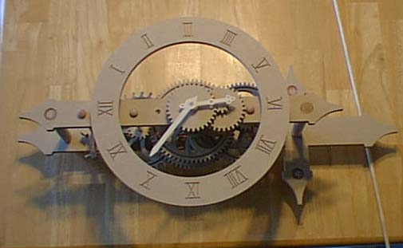
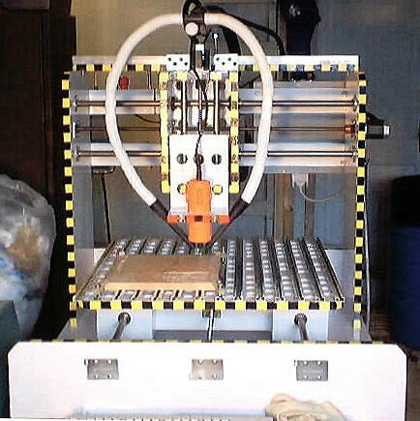
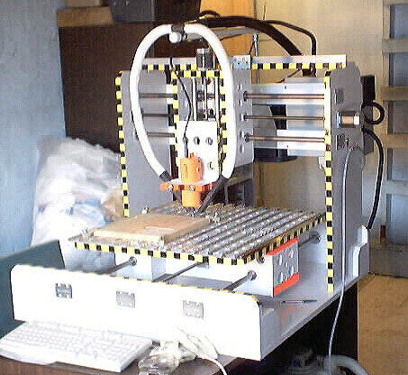
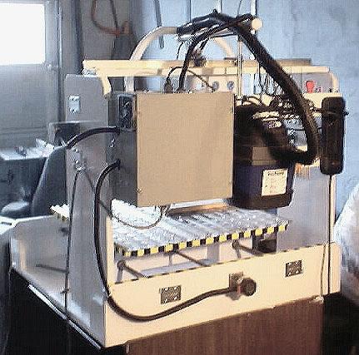
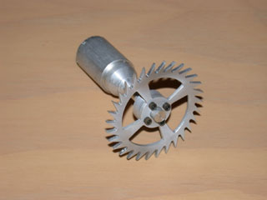
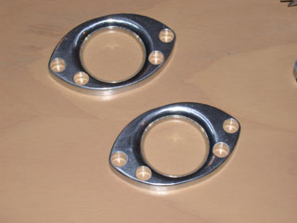
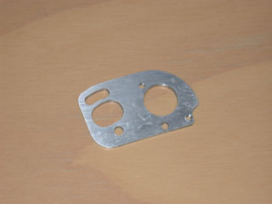
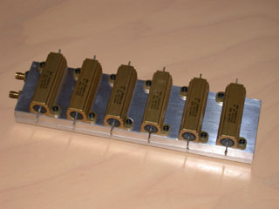
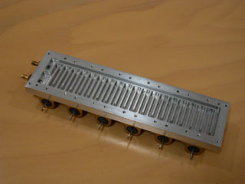
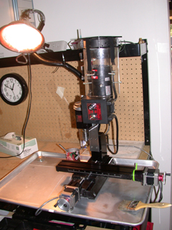
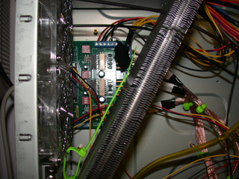
Thanks for the info I found it on the cd and I did go online and get the xp version. It works great.. thanks..again for the very fast reply on a Sunday!
I am amazed at what you can do with this board. I have two now.. one I play with and the other my brother and I run a rather large 10 ton 1980's NC copy mill. It is now a CNC by using the FET-4 board. I like CNCpro buy my brother likes the EMC because of the visual backplot while running programs. Both work good.
Here is what we use it on. The picture of the whole mill was taken just before we installed the three axis control via steppers. All of the adaptors and mounting brackets pictured were made by this mill (we had to make temporary brackets in order to mill new ones accurately).
Anyway I thought you might get a kick out of seeing what we use the FET-4 for, thanks again.
Bill
